1. buat sebuah halaman baru dan implementasikan date picker dan color picker seperti pada gambar dan video contoh pembuatan ada di alta.id

* InteractiveWidget.dart

import 'package:flutter/material.dart';

import 'package:flutter_colorpicker/flutter_colorpicker.dart';

import 'package:file_picker/file_picker.dart';

class InteractiveWidget extends StatefulWidget {

const InteractiveWidget({Key? key}) : super(key: key);

@override

State<InteractiveWidget> createState() => _InteractiveWidgetState();

}

class _InteractiveWidgetState extends State<InteractiveWidget> {

DateTime _selectedDate = DateTime.now();

Color pickerColor = Colors.blue;

Color currentColor = Colors.blue;

String? _fileName;

String? _filePath;

Future<void> _selectDate(BuildContext context) async {

final DateTime? picked = await showDatePicker(

context: context,

initialDate: _selectedDate,

firstDate: DateTime(1900),

lastDate: DateTime(2100),

);

if (picked != null && picked != _selectedDate) {

setState(() {

_selectedDate = picked;

});

}

}

void changeColor(Color color) {

setState(() => pickerColor = color);

}

void onColorChanged(Color color) {

setState(() => currentColor = color);

}

void _openFilePicker() async {

try {

FilePickerResult? result = await FilePicker.platform.pickFiles(

type: FileType.any,

allowMultiple: false,

);

if (result != null) {

setState(() {

_fileName = result.files.single.name;

_filePath = result.files.single.path;

});

}

} catch (e) {

print("Error while picking the file: " + e.toString());

}

}

@override

Widget build(BuildContext context) {

return Theme(

data: ThemeData(brightness: Brightness.light),

child: Scaffold(

appBar: AppBar(

title: const Text("Interactive Widgets"),

centerTitle: true,

),

body: Column(

mainAxisAlignment: MainAxisAlignment.start,

children: [

ListTile(

contentPadding:

const EdgeInsets.only(top: 10, left: 10, right: 10),

leading: const Text(

'Date',

style: TextStyle(

fontFamily: 'Roboto-Regular',

fontSize: 16,

color: Color(0xff1C1B1F),

fontWeight: FontWeight.bold,

),

),

trailing: TextButton(

onPressed: () => _selectDate(context),

child: const Text(

'Select',

style: TextStyle(

fontFamily: 'Roboto-Regular',

fontSize: 16,

fontWeight: FontWeight.bold,

// color: Color(0xff6750A4),

),

),

),

),

Container(

width: double.infinity,

padding: const EdgeInsets.only(left: 10),

child: Text(

'${_selectedDate.day}-${_selectedDate.month}-${_selectedDate.year}',

style: const TextStyle(

fontFamily: 'Roboto-Regular',

fontSize: 14,

color: Color(0xff49454F),

),

),

),

const SizedBox(height: 20.0),

Container(

width: double.infinity,

padding: const EdgeInsets.only(left: 10),

child: const Text(

'Color',

style: TextStyle(

fontFamily: 'Roboto-Regular',

fontSize: 16,

color: Color(0xff1C1B1F),

fontWeight: FontWeight.bold),

),

),

const SizedBox(height: 10.0),

Container(

width: double.infinity,

height: 50.0,

margin: const EdgeInsets.only(left: 10, right: 10),

decoration: BoxDecoration(

color: currentColor,

shape: BoxShape.rectangle,

borderRadius: BorderRadius.circular(5),

),

),

const SizedBox(height: 20.0),

RaisedButton(

color: currentColor,

shape: RoundedRectangleBorder(

borderRadius: BorderRadius.circular(5),

),

onPressed: () {

showDialog(

context: context,

builder: (BuildContext context) {

return AlertDialog(

title: const Text('Pick a color'),

content: SingleChildScrollView(

child: ColorPicker(

pickerColor: pickerColor,

onColorChanged: changeColor,

showLabel: true,

pickerAreaHeightPercent: 0.8,

),

),

actions: [

FlatButton(

child: const Text('Cancel'),

onPressed: () {

Navigator.of(context).pop();

},

),

FlatButton(

child: const Text('Apply'),

onPressed: () {

onColorChanged(pickerColor);

Navigator.of(context).pop();

},

),

],

);

},

);

},

child: const Text(

'Pick Color',

style: TextStyle(

fontFamily: 'Roboto-Regular',

fontSize: 16,

color: Colors.white,

),

),

),

const SizedBox(height: 20),

Container(

width: double.infinity,

padding: const EdgeInsets.only(left: 10),

child: const Text(

"Pick Files",

style: TextStyle(

fontFamily: 'Roboto-Regular',

fontSize: 16,

fontWeight: FontWeight.bold,

color: Color(0xff1C1B1F),

),

),

),

Text(

_fileName ?? "No file selected.",

),

RaisedButton(

onPressed: _openFilePicker,

color: Colors.blue,

shape: RoundedRectangleBorder(

borderRadius: BorderRadius.circular(5),

),

child: const Text(

"Pick and Open File",

style: TextStyle(

fontFamily: 'Roboto-Regular',

fontSize: 16,

color: Colors.white,

),

),

),

],

),

),

);

}

}

* Code Color Picker dan Date Picker :

Column(

mainAxisAlignment: MainAxisAlignment.start,

children: [

ListTile(

contentPadding:

const EdgeInsets.only(top: 10, left: 10, right: 10),

leading: const Text(

'Date',

style: TextStyle(

fontFamily: 'Roboto-Regular',

fontSize: 16,

color: Color(0xff1C1B1F),

fontWeight: FontWeight.bold,

),

),

trailing: TextButton(

onPressed: () => _selectDate(context),

child: const Text(

'Select',

style: TextStyle(

fontFamily: 'Roboto-Regular',

fontSize: 16,

fontWeight: FontWeight.bold,

// color: Color(0xff6750A4),

),

),

),

),

Container(

width: double.infinity,

padding: const EdgeInsets.only(left: 10),

child: Text(

'${_selectedDate.day}-${_selectedDate.month}-${_selectedDate.year}',

style: const TextStyle(

fontFamily: 'Roboto-Regular',

fontSize: 14,

color: Color(0xff49454F),

),

),

),

const SizedBox(height: 20.0),

Container(

width: double.infinity,

padding: const EdgeInsets.only(left: 10),

child: const Text(

'Color',

style: TextStyle(

fontFamily: 'Roboto-Regular',

fontSize: 16,

color: Color(0xff1C1B1F),

fontWeight: FontWeight.bold),

),

),

const SizedBox(height: 10.0),

Container(

width: double.infinity,

height: 50.0,

margin: const EdgeInsets.only(left: 10, right: 10),

decoration: BoxDecoration(

color: currentColor,

shape: BoxShape.rectangle,

borderRadius: BorderRadius.circular(5),

),

),

const SizedBox(height: 20.0),

RaisedButton(

color: currentColor,

shape: RoundedRectangleBorder(

borderRadius: BorderRadius.circular(5),

),

onPressed: () {

showDialog(

context: context,

builder: (BuildContext context) {

return AlertDialog(

title: const Text('Pick a color'),

content: SingleChildScrollView(

child: ColorPicker(

pickerColor: pickerColor,

onColorChanged: changeColor,

showLabel: true,

pickerAreaHeightPercent: 0.8,

),

),

actions: [

FlatButton(

child: const Text('Cancel'),

onPressed: () {

Navigator.of(context).pop();

},

),

FlatButton(

child: const Text('Apply'),

onPressed: () {

onColorChanged(pickerColor);

Navigator.of(context).pop();

},

),

],

);

},

);

},

child: const Text(

'Pick Color',

style: TextStyle(

fontFamily: 'Roboto-Regular',

fontSize: 16,

color: Colors.white,

),

),

),

Output :

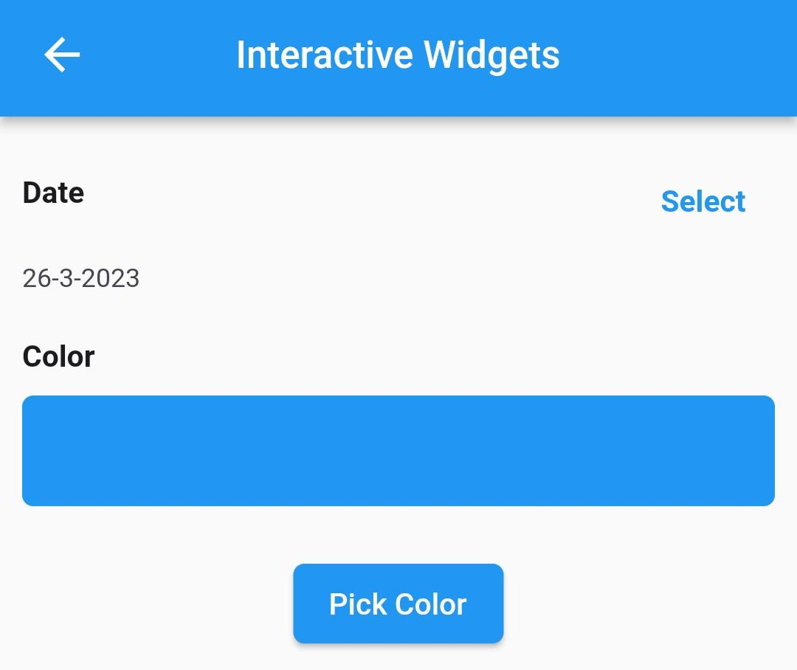

Penjelasan :

Disini saya menggunakan fitur showDatePicker() untuk menampilkan DatePicker, dan mengambil date sesuai dengan tanggal saat ini. Untuk ColorPicker saya menggunakan package flutter color picker.

1. implementasikan file picker seperti yang di contohkan pada video

Container(

width: double.infinity,

padding: const EdgeInsets.only(left: 10),

child: const Text(

"Pick Files",

style: TextStyle(

fontFamily: 'Roboto-Regular',

fontSize: 16,

fontWeight: FontWeight.bold,

color: Color(0xff1C1B1F),

),

),

),

Text(

_fileName ?? "No file selected.",

),

RaisedButton(

onPressed: _openFilePicker,

color: Colors.blue,

shape: RoundedRectangleBorder(

borderRadius: BorderRadius.circular(5),

),

child: const Text(

"Pick and Open File",

style: TextStyle(

fontFamily: 'Roboto-Regular',

fontSize: 16,

color: Colors.white,

),

),

),

Output :

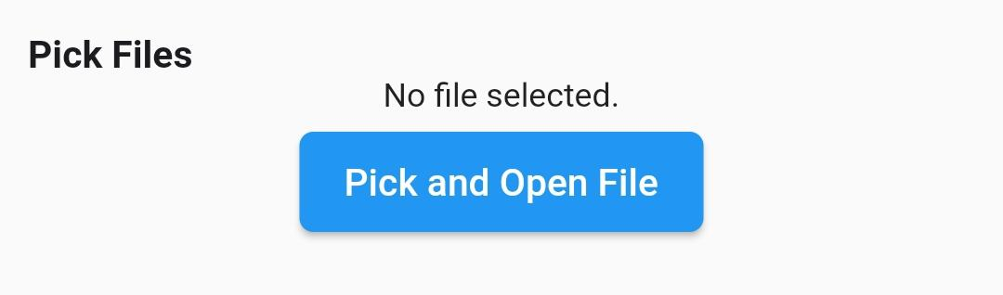

Penjelasan :

Disini saya menggunakan package file picker untuk membuat FilePicker